**E009**

**DHRUMIL BURAD**

**MWA ASSIGNMENT 2**

**1. Create percentage calculator for semester IV. User will enter no of courses and clcik submit button. Thos many number fields must be generated dynamically. User will enter marks of each course and the calculate percentage. (Hint:Use DOM methods createElement(),setAttributes(), createTextNode(), appendChild())**

## CODE

<!DOCTYPE html>

<html lang="en">

<head>

    <meta charset="UTF-8">

    <meta http-equiv="X-UA-Compatible" content="IE=edge">

    <meta name="viewport" content="width=device-width, initial-scale=1.0">

    <title>Assignment 2 Q1 </title>

</head>

<body>

    <strong>

        <p>Q1 Create percentage calculator for semester IV. User will enter no of courses and clcik submit button. Thos

            many

            number fields must be generated dynamically. User will enter marks of each course and the calculate

            percentage.

            (Hint:Use DOM methods createElement(),setAttributes(), createTextNode(), appendChild())</p>

    </strong>

    Enter Number of courses: <input type="number" id="noc">

    <button id="s1" onclick="create()">Submit</button>

    <p id="inps"></p>

    <p id="op"></p>

    <script>

        function create() {

            let x = parseInt(document.getElementById("noc").value)

            let i = 0;

            console.log(x)

            let p = document.getElementById("inps")

            p.innerHTML = ""

            for (i = 1; i <= x; i++) {

                var m = document.createTextNode("Marks for Course " + i + ": ")

                var y = document.createElement("input")

                y.setAttribute("type", "text")

                y.setAttribute("id", i)

                p.appendChild(m)

                p.appendChild(y)

                p.appendChild(document.createElement("br"))

                p.appendChild(document.createElement("br"))

            }

            var cb = document.createElement("button")

            cb.setAttribute("onclick", "calc()")

            cb.innerHTML = "submit";

            p.appendChild(cb)

        }

        function calc() {

            let i = 0

            let sum = 0

            let x = parseInt(document.getElementById("noc").value)

            for (i = 1; i <= x; i++) {

                var a = document.getElementById(i).value

                console.log(i)

                sum += (a / x)

                console.log(sum)

            }

            let ss = sum.toFixed(2);

            let o = document.getElementById("op")

            op.innerHTML = "The percentage is : " + ss + "%"

        }

    </script>

</body>

</html>

## SCREENSHOT

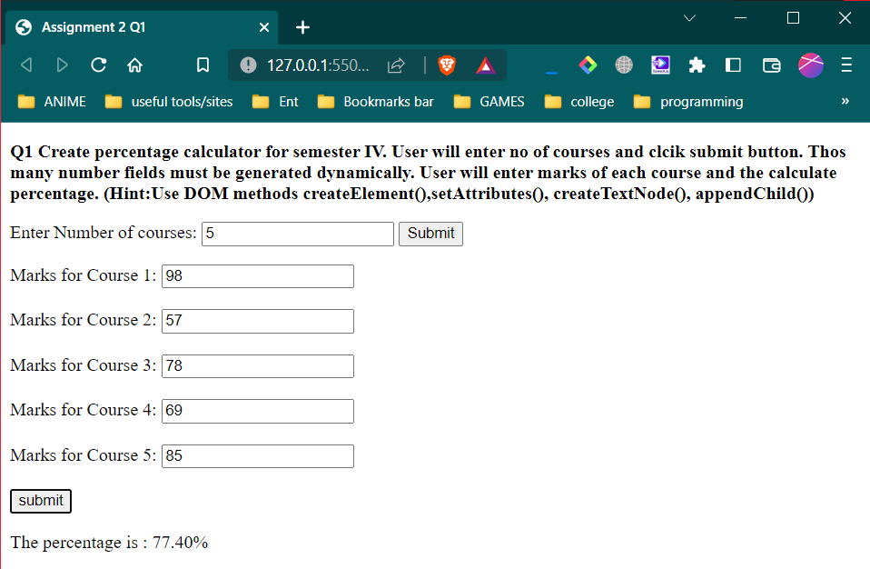

**2. Create an application to print no of days left for next Christmas (Hint: use date object in js)**

## CODE

<!DOCTYPE html>

<html lang="en">

<head>

    <meta charset="UTF-8">

    <meta http-equiv="X-UA-Compatible" content="IE=edge">

    <meta name="viewport" content="width=device-width, initial-scale=1.0">

    <title>Assignment 2 Q2</title>

</head>

<body>

    <P><strong> 2. Create an application to print no of days left for next Christmas(Hint: use date object in

            js)</strong></P>

    <button onclick="calc()">GET DATE</button><br>

    Today's date: <span id="td"> </span><br>

    No. of days left for next christmas: <span id="op"> </span>

    <script>

        function calc() {

            var d = new Date

            document.getElementById("td").innerHTML = ""

            document.getElementById("td").innerHTML += d

            console.log("hours", d.getHours())

            const c = new Date(2023, 11, 25);

            let ms = 24 * 60 * 60 * 1000

            console.log("ms", d.getTime())

            console.log("ms c", c.getTime())

            var l = Math.ceil((c.getTime() - d.getTime()) / ms)

            document.getElementById("op").innerHTML = ""

            document.getElementById("op").innerHTML += l.toFixed(2)

*/*  console.log(ms)*

*var a = d.getDate()*

*var b = d.getMonth()*

*console.log(a, b)*

*console.log("c", c)*

*var n = d - c*

*console.log("n", n)*

*console.log(a) */*

        }

    </script>

</body>

</html>

## SCREENSHOT

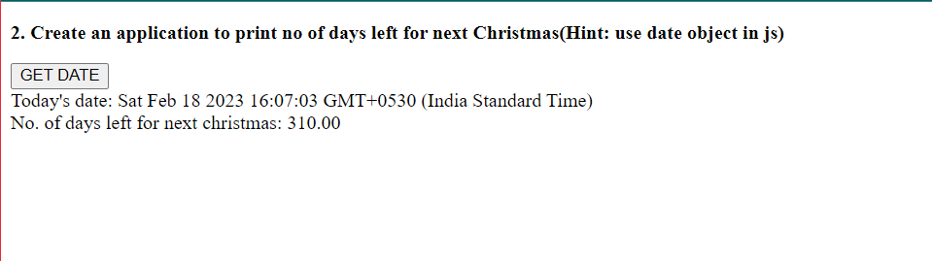

**3. Create an application to print mouse coordinates.**

## CODE

<!DOCTYPE html>

<html lang="en">

<head>

    <meta charset="UTF-8">

    <meta http-equiv="X-UA-Compatible" content="IE=edge">

    <meta name="viewport" content="width=device-width, initial-scale=1.0">

    <title>Assignment 2 Q2 </title>

</head>

<body style="height: 5550px;" onmousemove="coord()">

    <p><strong>3. Create an application to print mouse coordinates.</strong></p>

    <span>X-Coordinate:</span>

    <span id="xco"> </span> <br>

    <span>Y-Coordinate:</span>

    <span id="yco"> </span>

    <script>

        function coord() {

            var x = event.clientX;

            var y = event.clientY;

            document.getElementById("xco").innerHTML = x;

            document.getElementById("yco").innerHTML = y;

        }

    </script>

</body>

</html>

## SCREENSHOT

